Name: Willie Frank McCorvey
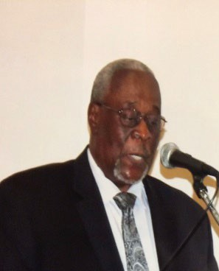

- Position: Treasurer
Professional Background: For forty years, Willie Frank McCorvey held various supervisory positions, including Production Planner, raw material scheduler-expeditor, and relief yard supervisor at Armstrong World Industries, Inc. He worked both in Fabrication and the Laboratory before assuming the supervisory positions. At Armstrong, he received numerous Awards for Excellence and Thank-You Awards for quality performance. He was recognized as Employee of the Year and was given a trip to a Ski Resort in Denver, Colorado. As the Production Planner, he was given a trip to Amelia Island in Nassau County, Florida. For several years, he served as the United Way Campaign Coordinator for Armstrong, where United Way recognized him for his leadership in exceeding the company’s goal in contributions. Willie also served as a coach for Bill Bond All-Stars, who won the Pensacola District League tournament and was a semi-finalist in the Florida Major Little League tournament held in Tallahassee, Florida.

Education:
  - A.A. from Pensacola State College in Pensacola, Florida
- Skills and Expertise: Trained at the Lancaster, Pennsylvania Headquarters, and the local plant as a Laboratory Technician, Inventory Control and Procurement Supervisor, and Production Planner.
- Community Involvement: Willie Frank currently serves as the Treasurer of the Mount Olive Faith-Based Community Information Center Secretary, focusing on empowering and uplifting the community through accessible information and support services.
- Contact Information: wfmccorvey@bellsouth.net

