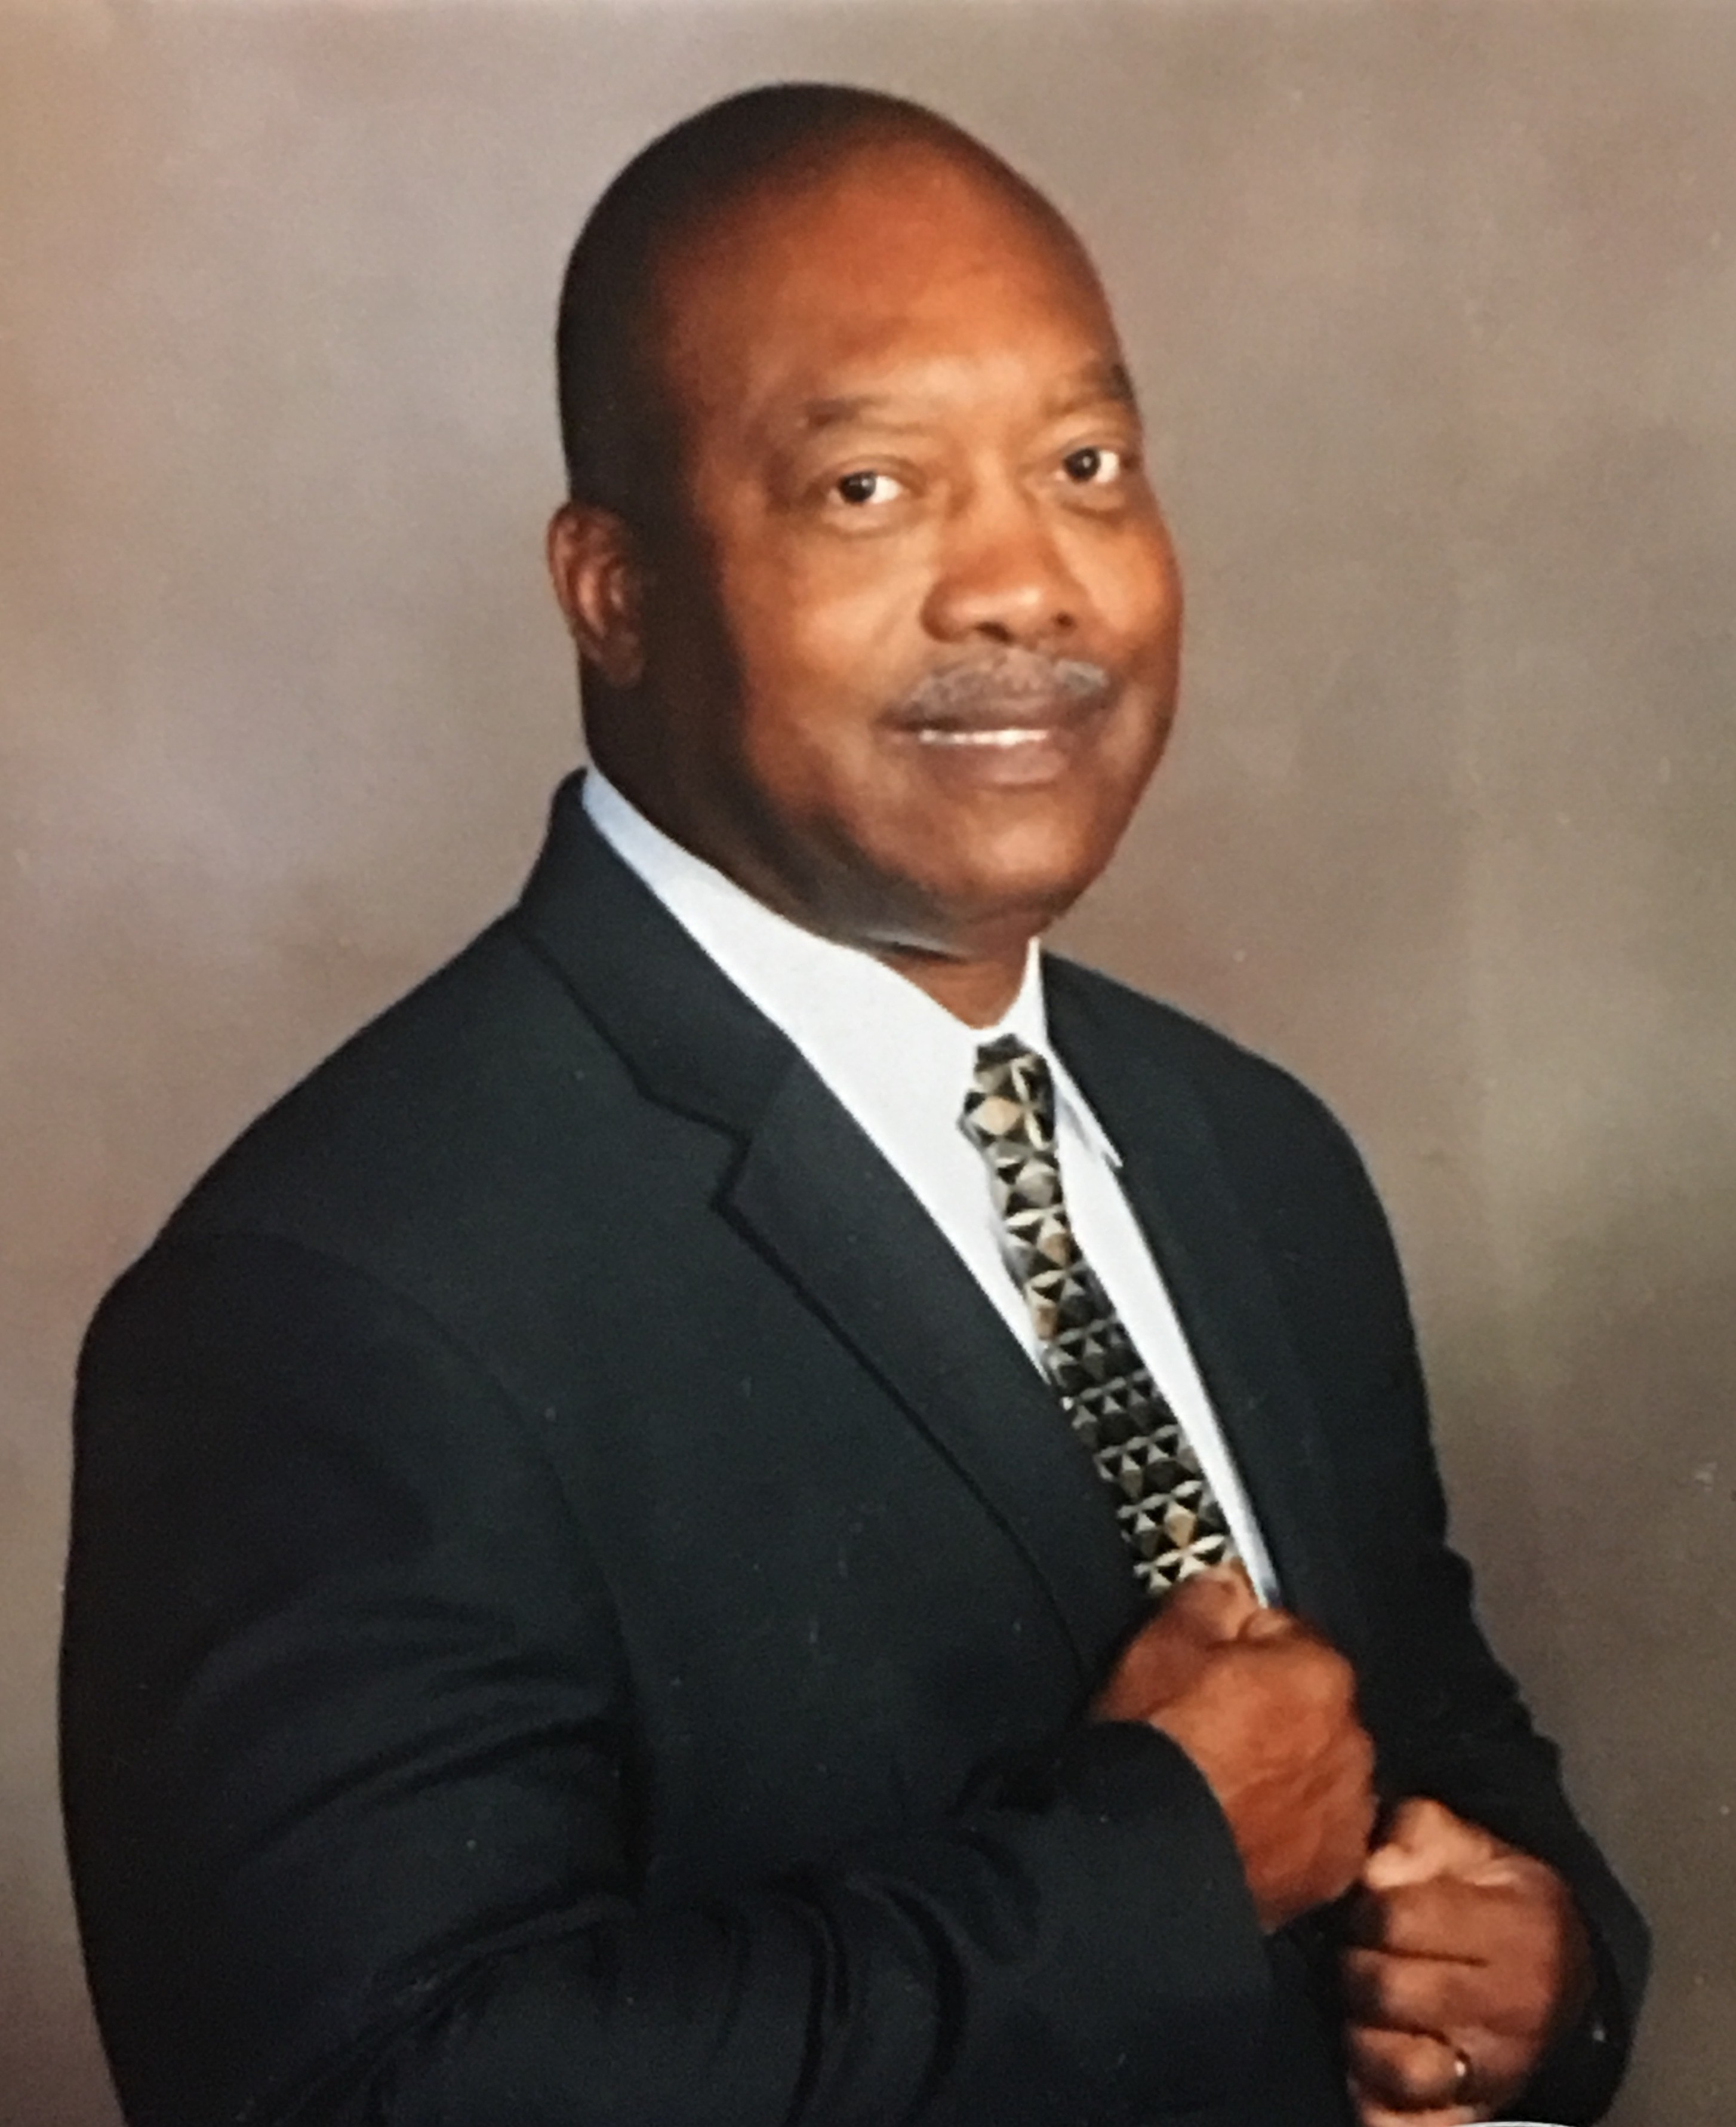
- Name Lewis Anderson
  - Position: Chair of the Board/President
- Professional Background: Lewis is a retired Navy Surface Warfare Officer. After naval service, Lewis worked in banking and was a Mcdonald’s franchisee prior to retirement.
- Education: National University, MBA ; Dillard University, BA
- Skills and Expertise: Played college basketball at Dillard University
- Community Involvement: Former V.P. of Pensacola NAACP chapter. Member of Board of Directors, Pensacola Alumni Chapter of Kappa Alpha Psi fraternity and V.P of Delta Pi Boulé of Sigma Pi Phi fraternity
- Contact Information: lewiseanderson1911@gmail.com

